ASSIGNMENT-1

QUE-1 CODE

def reverse_string(input_string):  
 *# Initialize an empty string for the reversed string* reversed_string = ''  
  
 *# Loop through the original string in reverse order* for i in range(len(input_string) - 1, -1, -1):  
 reversed_string += input_string[i]  
  
 return reversed_string  
  
  
*# Sample Input and Test Cases*test_cases = [  
 "TEMPLE",  
 "SIGN UP",  
 "AT-LEAST",  
 "1245",  
 "!@#$%",  
 "145*999=144855"  
]  
  
*# Applying the reverse_string function to each test case and printing the results*for case in test_cases:  
 print(f"Original String: {case}")  
 print(f"Reversed String: {reverse_string(case)}")  
 print() *# Print a newline for better readability*

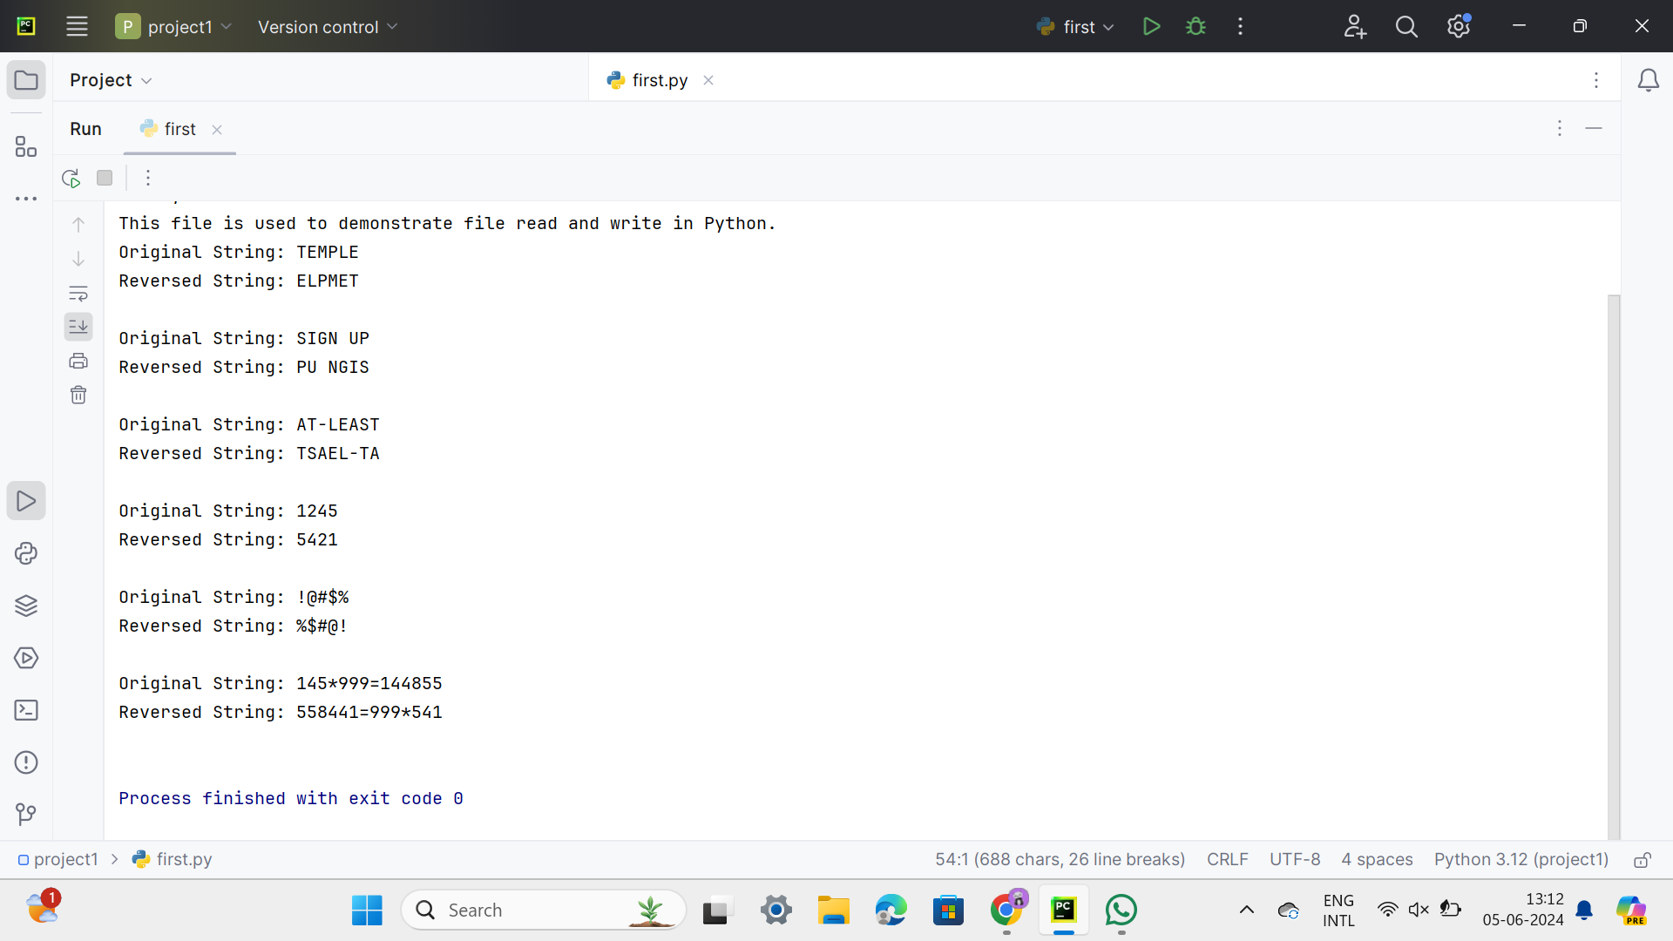

QUE-2

CODE

def calculate_pow(x, n):

result = 1

for _ in range(n):

result *= x

return result

def calculate_add(x, n):

return x + n

def calculate_sub(x, n):

return x - n

def calculate_mul(x, n):

return x * n

def calculate_div(x, n):

if n == 0:

return "Division by zero is undefined"

return x / n

def main():

x = int(input("Enter the value for X: "))

n = int(input("Enter the value for N: "))

print("Choose the operation:")

print("1. Power (Pow(x, n))")

print("2. Addition (Add(x, n))")

print("3. Subtraction (Sub(x, n))")

print("4. Multiplication (Mul(x, n))")

print("5. Division (Div(x, n))")

choice = int(input("Enter your choice (1-5): "))

if choice == 1:

print(f"Pow({x}, {n}) = {calculate_pow(x, n)}")

elif choice == 2:

print(f"Add({x}, {n}) = {calculate_add(x, n)}")

elif choice == 3:

print(f"Sub({x}, {n}) = {calculate_sub(x, n)}")

elif choice == 4:

print(f"Mul({x}, {n}) = {calculate_mul(x, n)}")

elif choice == 5:

print(f"Div({x}, {n}) = {calculate_div(x, n)}")

else:

print("Invalid choice!")

if __name__ == "__main__":

main()

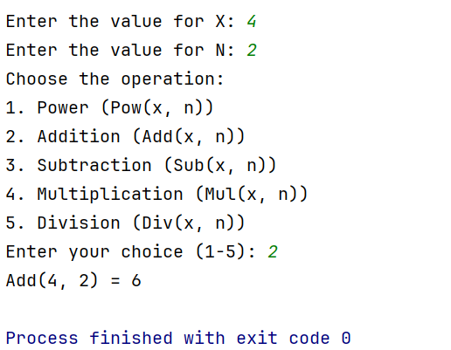

QUE-3

CODE-

def is_prime(num):

if num <= 1:

return False

if num == 2:

return True

if num % 2 == 0:

return False

for i in range(3, int(num**0.5) + 1, 2):

if num % i == 0:

return False

return True

def count_prime_composite(numbers):

prime_count = 0

composite_count = 0

for num in numbers:

try:

num = int(num)

if num > 1:

if is_prime(num):

prime_count += 1

else:

composite_count += 1

except ValueError:

# Skip non-integer inputs

continue

return prime_count, composite_count

def main():

# Input from user

user_input = input("Enter the numbers (separated by spaces or commas): ")

# Splitting the input into a list of strings

numbers = user_input.replace(',', ' ').split()

# Counting prime and composite numbers

prime_count, composite_count = count_prime_composite(numbers)

# Output the result

print(f"Composite numbers: {composite_count}")

print(f"Prime numbers: {prime_count}")

if __name__ == "__main__":

main()

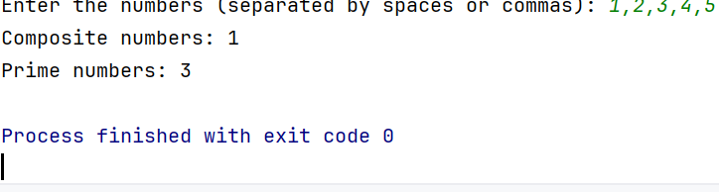

QUE-4

CODE-

def is_valid_username(username):

# Check length of username

if len(username) < 3 or len(username) > 15:

return False

# Check if the username contains only alphanumeric characters

if not username.isalnum():

return False

# Check if the username does not start with a number

if username[0].isdigit():

return False

return True

def main():

# Get username input from the user

username = input("Enter the username: ")

# Check if the username is valid

if is_valid_username(username):

print("The entered username is valid.")

else:

print("The entered username is not valid.")

if __name__ == "__main__":

main()

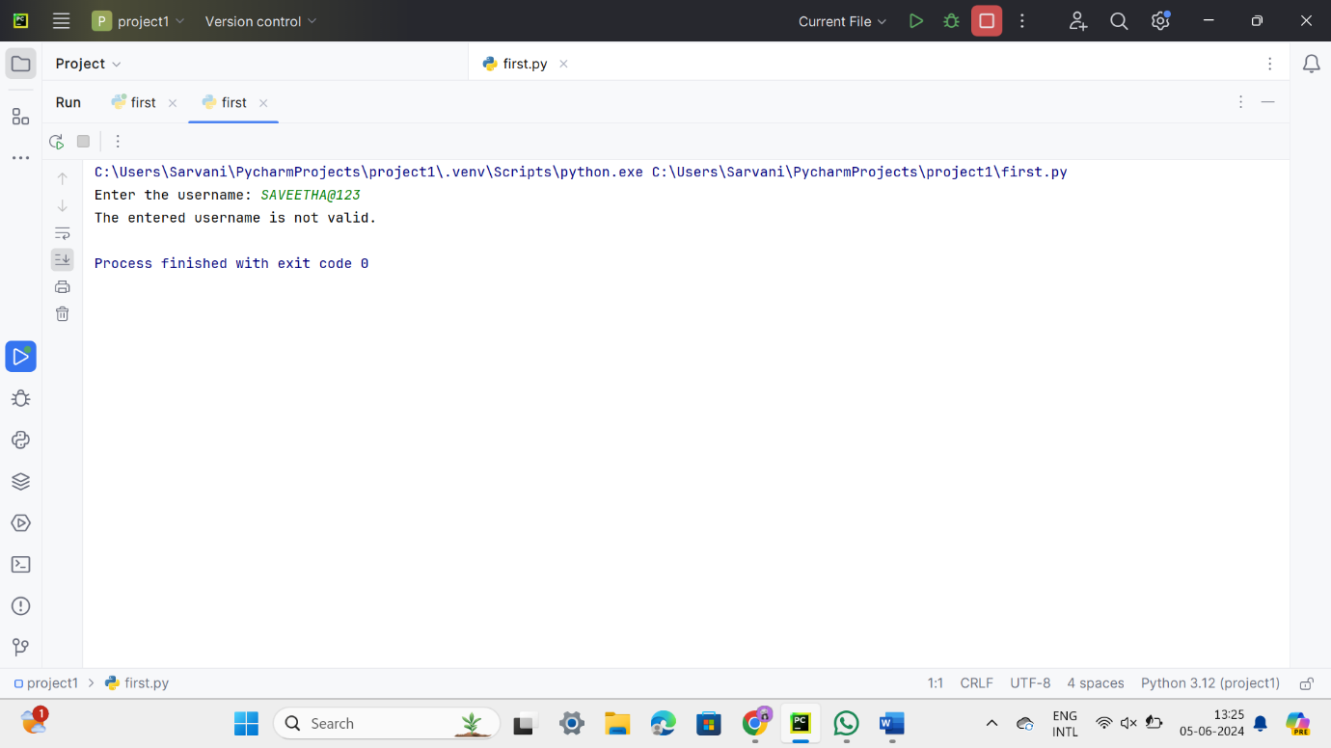

QUE-5

CODE-

def find_mth_maximum(arr, M):

# Sort the array in descending order and return the Mth maximum element

sorted_arr = sorted(arr, reverse=True)

if M <= 0 or M > len(sorted_arr):

return None

return sorted_arr[M-1]

def find_nth_minimum(arr, N):

# Sort the array in ascending order and return the Nth minimum element

sorted_arr = sorted(arr)

if N <= 0 or N > len(sorted_arr):

return None

return sorted_arr[N-1]

def main():

# Sample input

arr = [14, 16, 87, 36, 25, 89, 34]

M = 1

N = 3

# Find Mth maximum and Nth minimum

mth_max = find_mth_maximum(arr, M)

nth_min = find_nth_minimum(arr, N)

if mth_max is not None and nth_min is not None:

# Calculate sum and difference

sum_result = mth_max + nth_min

difference_result = mth_max - nth_min

# Print the results

print(f"{M}th Maximum Number = {mth_max}")

print(f"{N}th Minimum Number = {nth_min}")

print(f"Sum = {sum_result}")

print(f"Difference = {difference_result}")

else:

print("Invalid M or N value for the given array length.")

if __name__ == "__main__":

main()

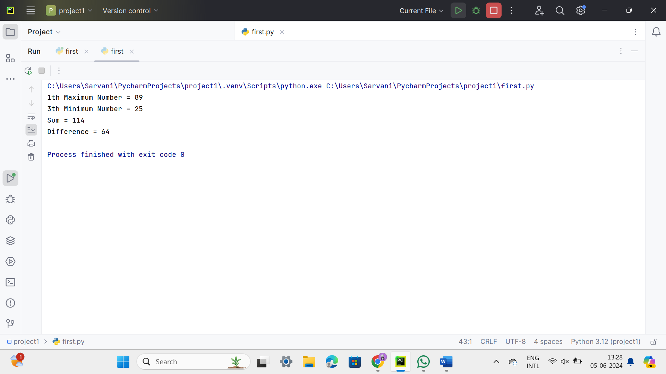

QUE-6

CODE-

def reverse_number(number):

# Check if the number is negative

is_negative = number < 0

if is_negative:

number = -number # Make the number positive for reversal

reversed_number = 0

while number > 0:

digit = number % 10

reversed_number = reversed_number * 10 + digit

number = number // 10

if is_negative:

reversed_number = -reversed_number # Restore the negative sign

return reversed_number

def main():

user_input = input("Enter the number: ")

try:

number = int(user_input)

reversed_number = reverse_number(number)

print(f"Reverse Number: {reversed_number}")

except ValueError:

print("Invalid input. Please enter a valid integer.")

if __name__ == "__main__":

main()

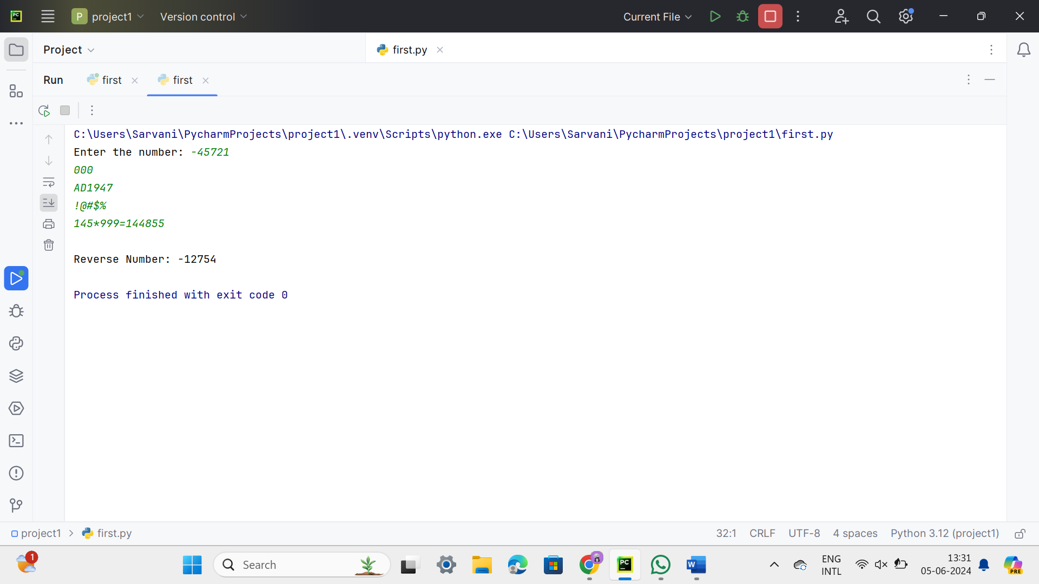

QUE-7

CODE-

def check_voting_eligibility(age):

try:

age = float(age)

if age < 0:

return "Invalid input. Age cannot be negative."

if age % 1 != 0:

return "Invalid input. Age should be a whole number."

age = int(age)

if age >= 18:

return "You are eligible to vote."

else:

years_left = 18 - age

return f"You are allowed to vote after {years_left} years."

except ValueError:

return "Invalid input. Please enter a valid age."

def main():

user_input = input("Enter your age: ")

result = check_voting_eligibility(user_input)

print(result)

if __name__ == "__main__":

main()

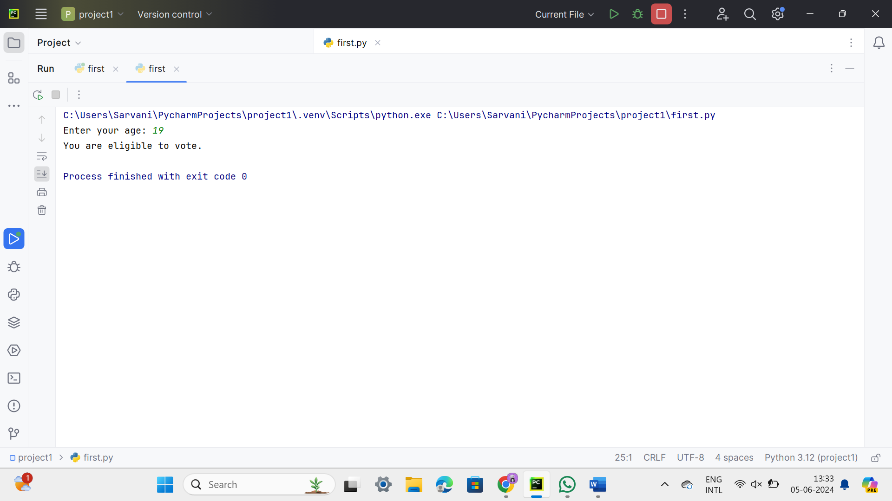

QUE-8

CODE-

def calculate_atm_balance(denominations, notes):

total_balance = 0

for denomination, count in zip(denominations, notes):

total_balance += denomination * count

return total_balance

def main():

denominations = []

notes = []

for i in range(1, 5):

try:

denomination = int(input(f"Enter the {i}st Denomination: "))

if denomination not in [2000, 500, 200, 100]:

print("Invalid denomination entered. Please enter one of the following: 2000, 500, 200, 100.")

return

num_notes = int(input(f"Enter the {i}st Denomination number of notes: "))

if num_notes < 0:

print("The number of notes cannot be negative.")

return

denominations.append(denomination)

notes.append(num_notes)

except ValueError:

print("Invalid input. Please enter valid numbers.")

return

total_balance = calculate_atm_balance(denominations, notes)

print(f"Total Available Balance in ATM: {total_balance}")

if __name__ == "__main__":

main()

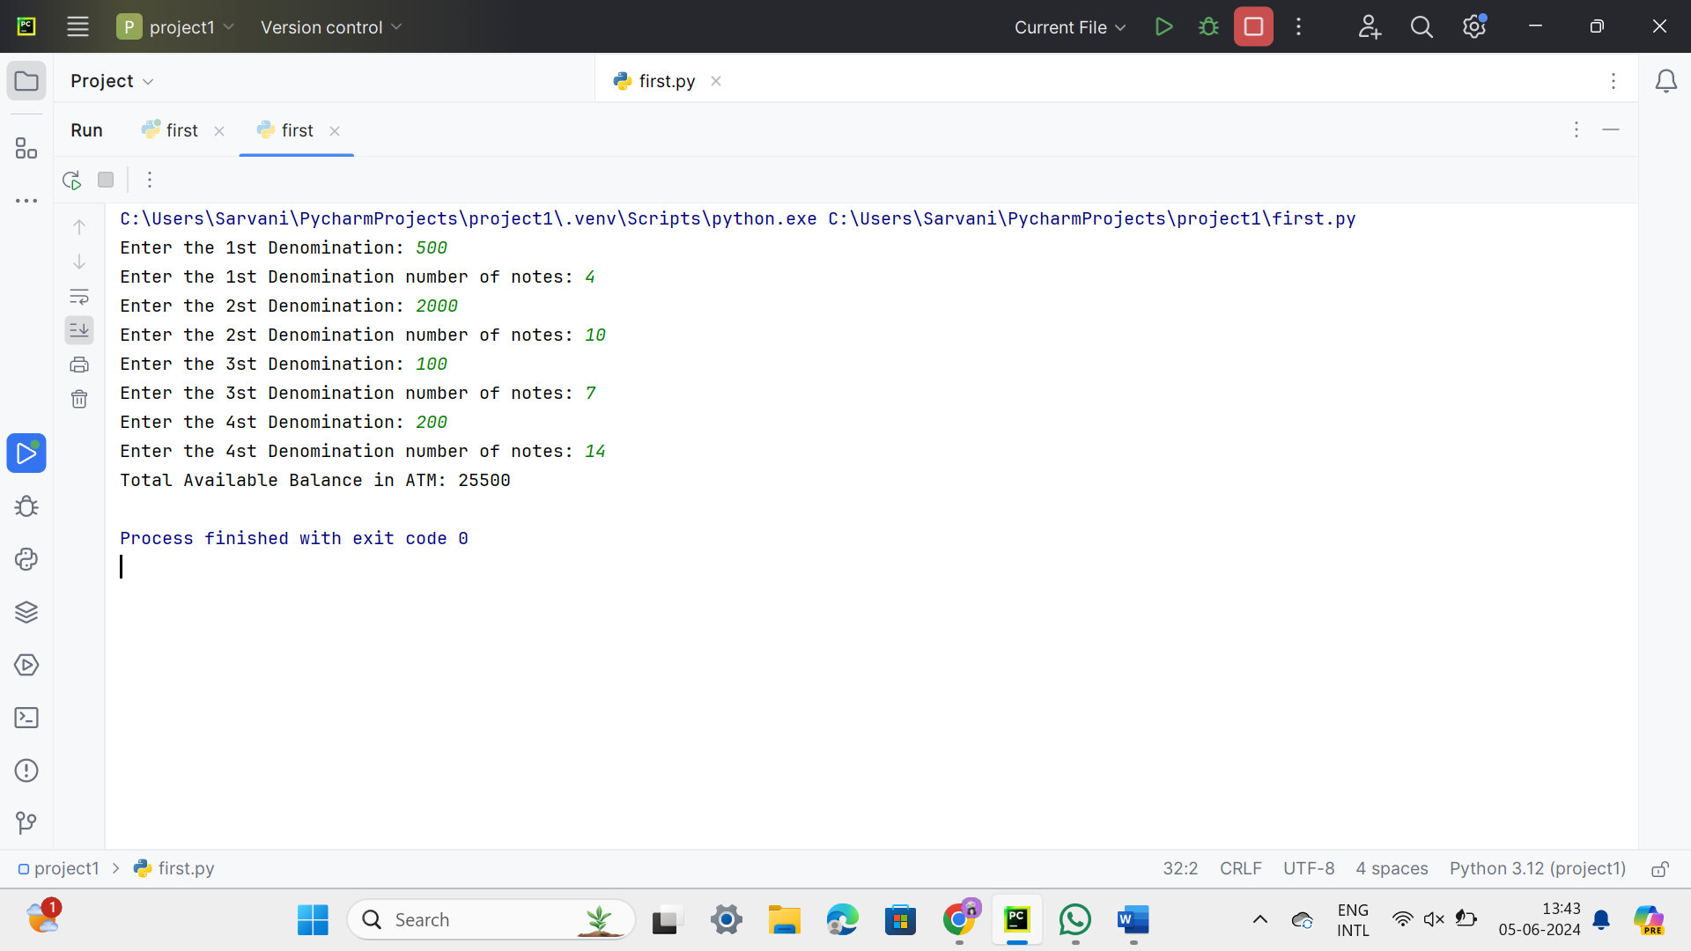

QUE-9

CODE-

def is_palindrome_string(s):  
 s = s.lower().replace(" ", "")  
 return s == s[::-1]  
  
def is_palindrome_number(n):  
 n = str(n)  
 return n == n[::-1]  
  
def main():  
 choice = input("Enter 1 to check string palindrome, 2 to check number palindrome: ")  
  
 if choice == '1':  
 user_input = input("Enter the string: ")  
 if is_palindrome_string(user_input):  
 print("Palindrome")  
 else:  
 print("Not a palindrome")  
 elif choice == '2':  
 user_input = input("Enter the number: ")  
 try:  
 float(user_input) *# Validate the input is a number* if is_palindrome_number(user_input):  
 print("Palindrome")  
 else:  
 print("Not a palindrome")  
 except ValueError:  
 print("Invalid input. Please enter a valid number.")  
 else:  
 print("Invalid choice. Please enter 1 or 2.")  
  
if __name__ == "__main__":  
 main()

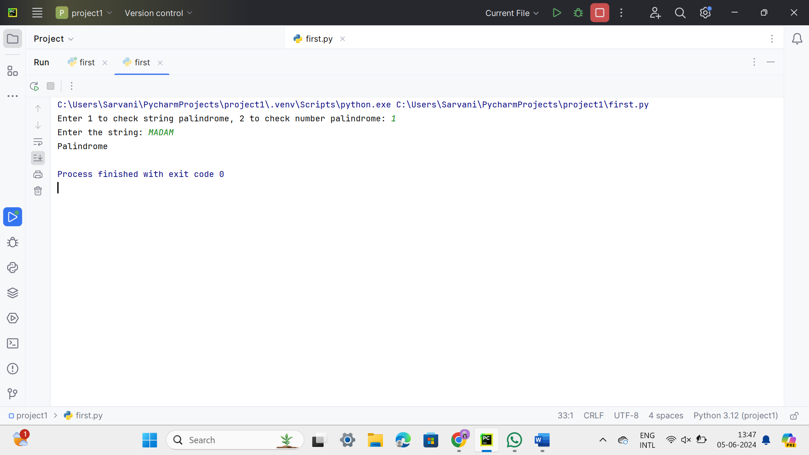

QUE-10

CODE-

import math

from functools import reduce

def gcd_multiple(numbers):

return reduce(math.gcd, numbers)

def lcm(a, b):

return abs(a * b) // math.gcd(a, b)

def lcm_multiple(numbers):

return reduce(lcm, numbers)

def main():

try:

n = int(input("Enter the N value: "))

if n <= 0:

print("N should be a positive integer.")

return

numbers = []

for i in range(n):

num = int(input(f"Enter number {i + 1}: "))

numbers.append(num)

gcd_result = gcd_multiple(numbers)

lcm_result = lcm_multiple(numbers)

print(f"LCM = {lcm_result}")

print(f"GCD = {gcd_result}")

except ValueError:

print("Invalid input. Please enter valid integers.")

if __name__ == "__main__":

main()

